Data Lake.
Step 01: Creating table in SQL Server:
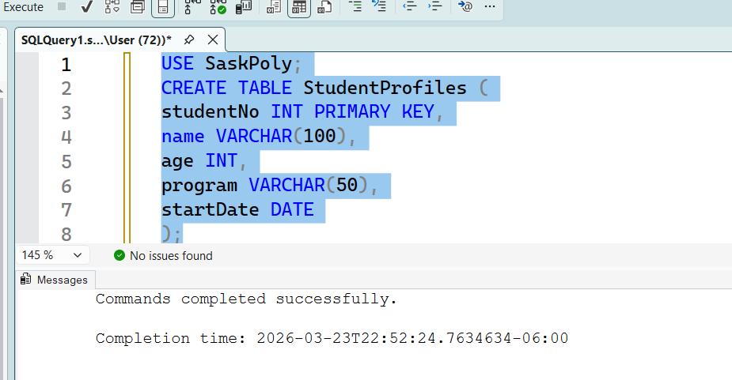
Inserting data into SQL table:
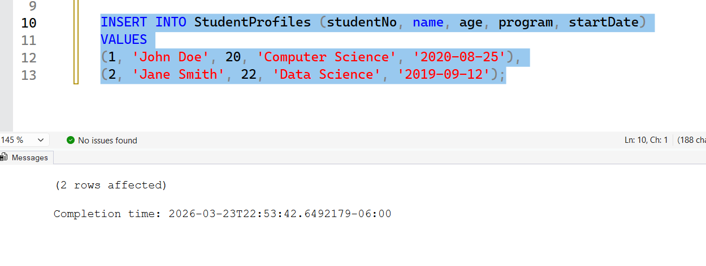
Displaying data with query in SQL.
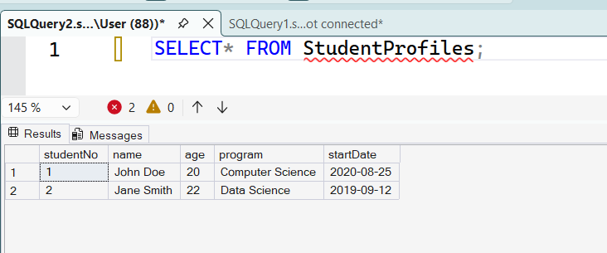
Step2: MongoDB Set up
Creating database and two collection named activityLogs and mediaFiles.
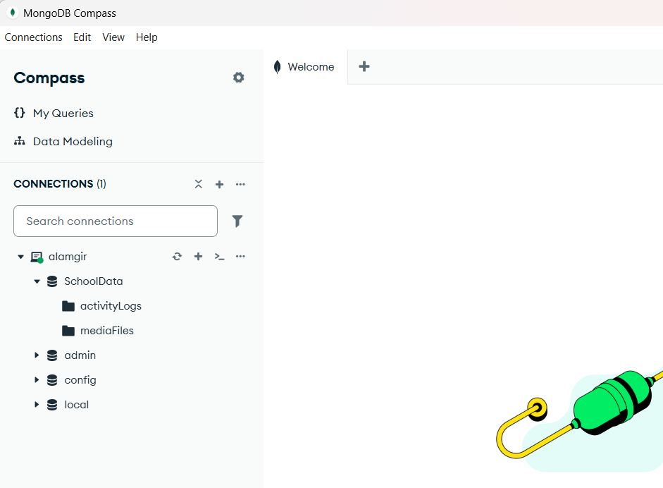

Populating data into MongoDB collection:
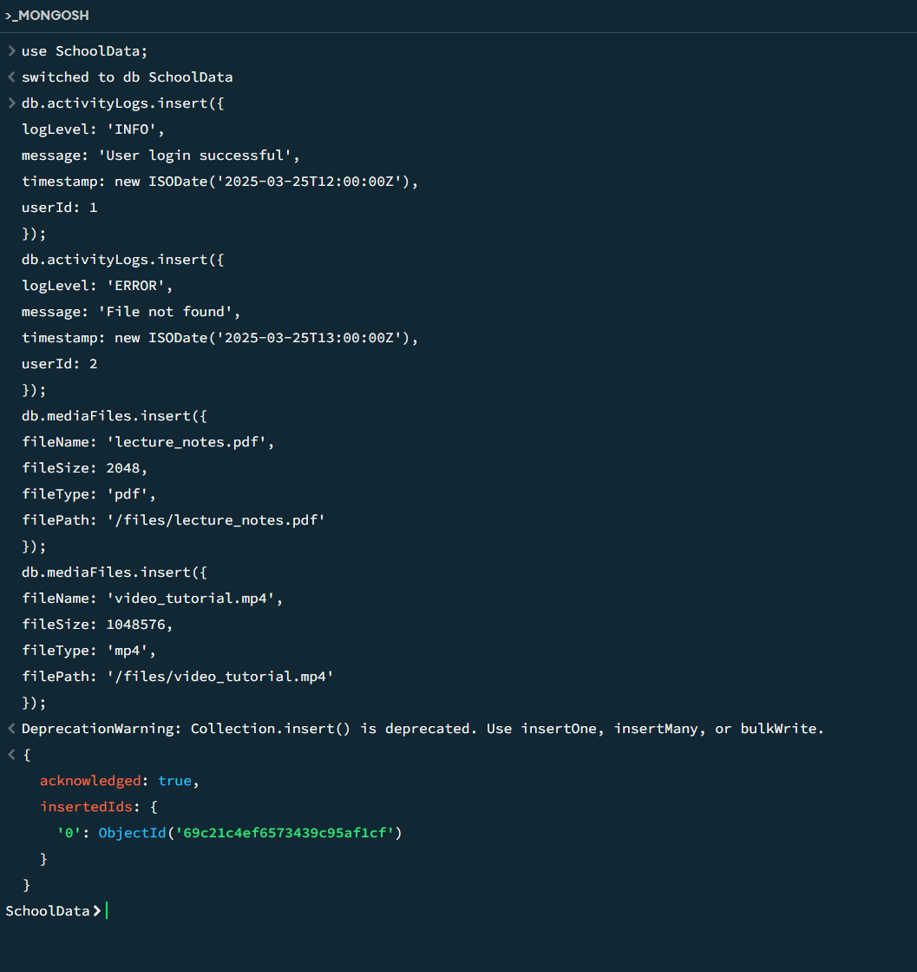

Step3: Prepare the Data Lake:
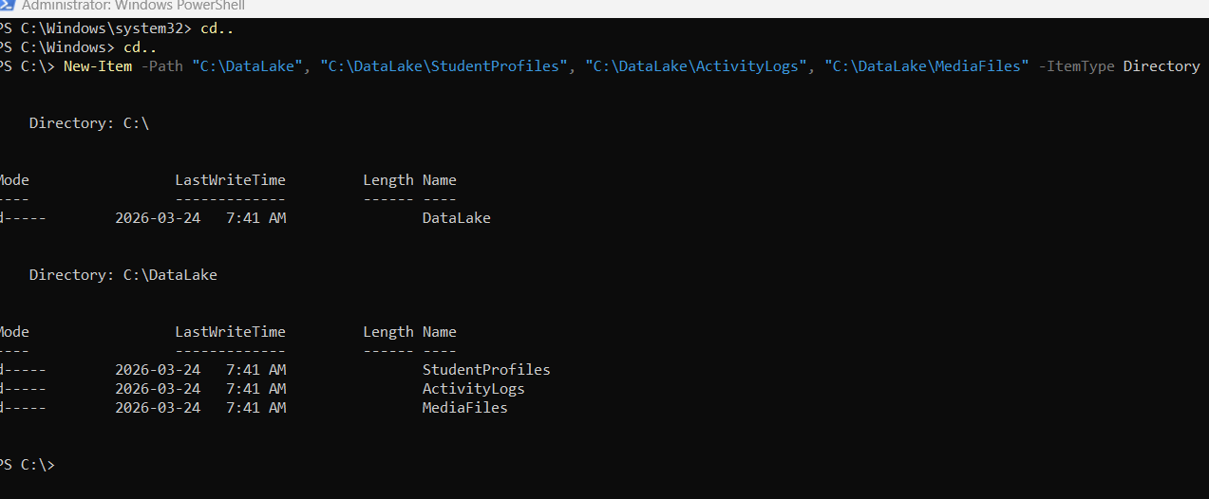
DataLake Created:
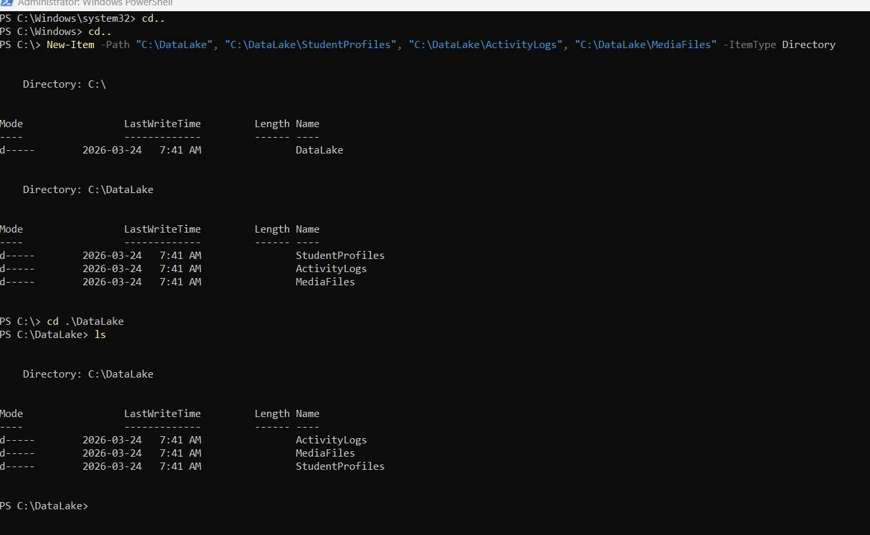

Step4: SQL integration setting up:
SQL SSIS installation:
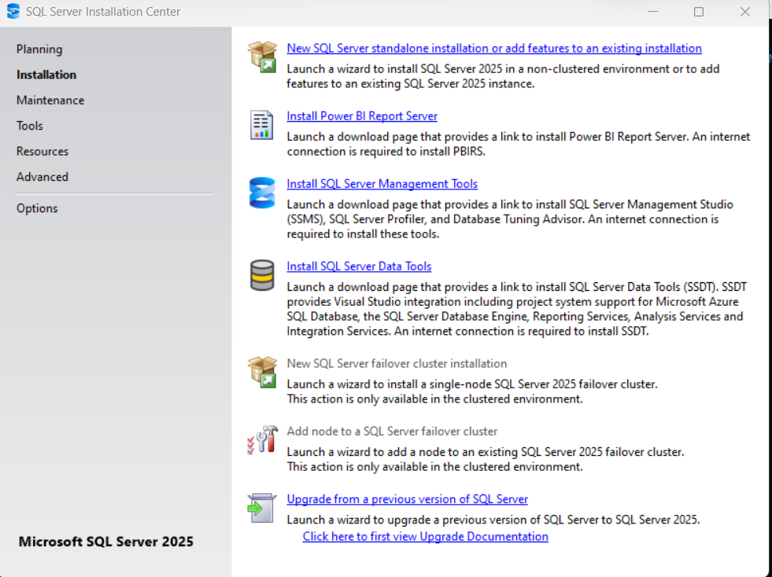
Completed:
SSIS Installation:
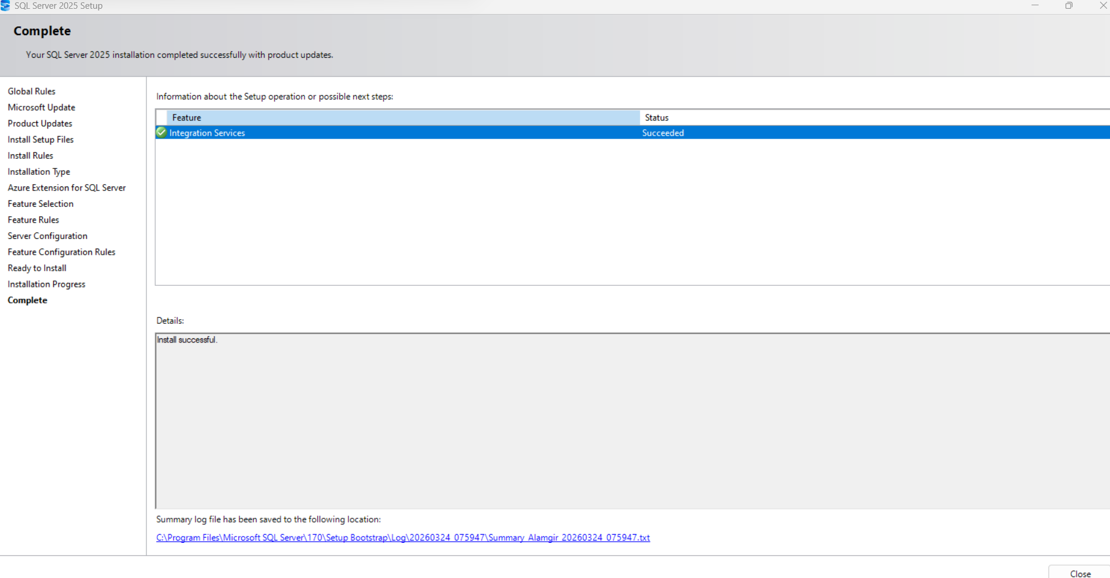
Visual Studio setting up:
Data storage and processing package installation:
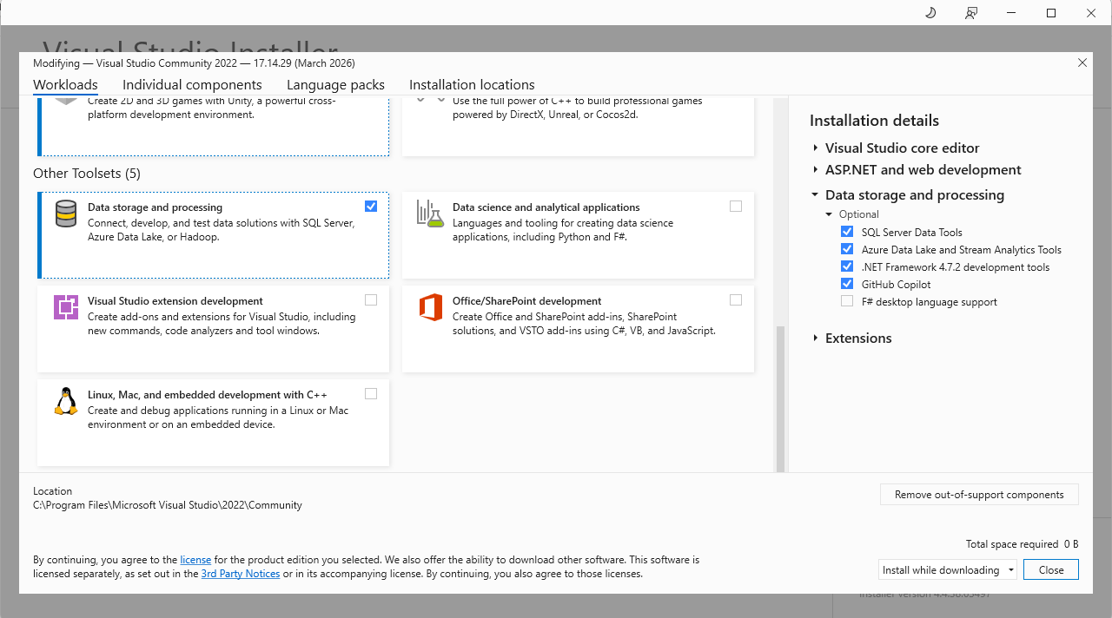
SQL server Integration Services Projects installation:
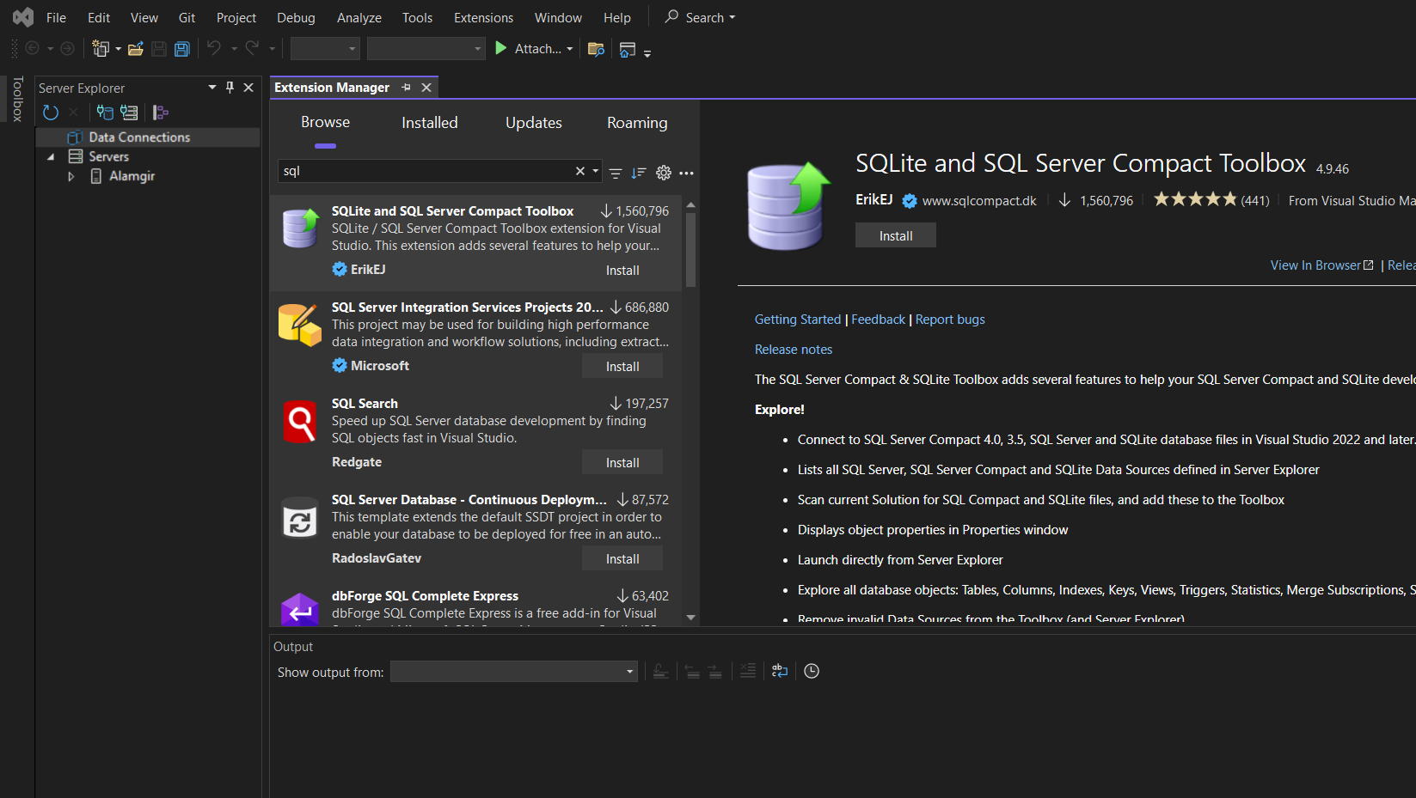

Step5: Project in Visual Studio:
01.Create New project (integration services project, select ETL)
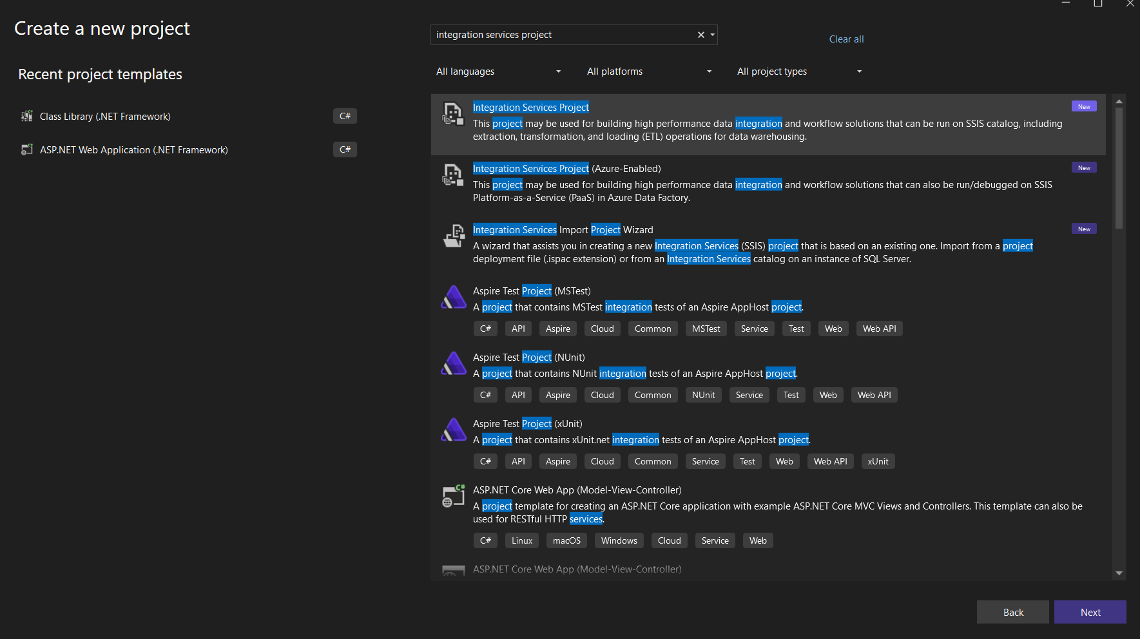
Creating OLE DB Source, connection and flat file (for destination) creation:
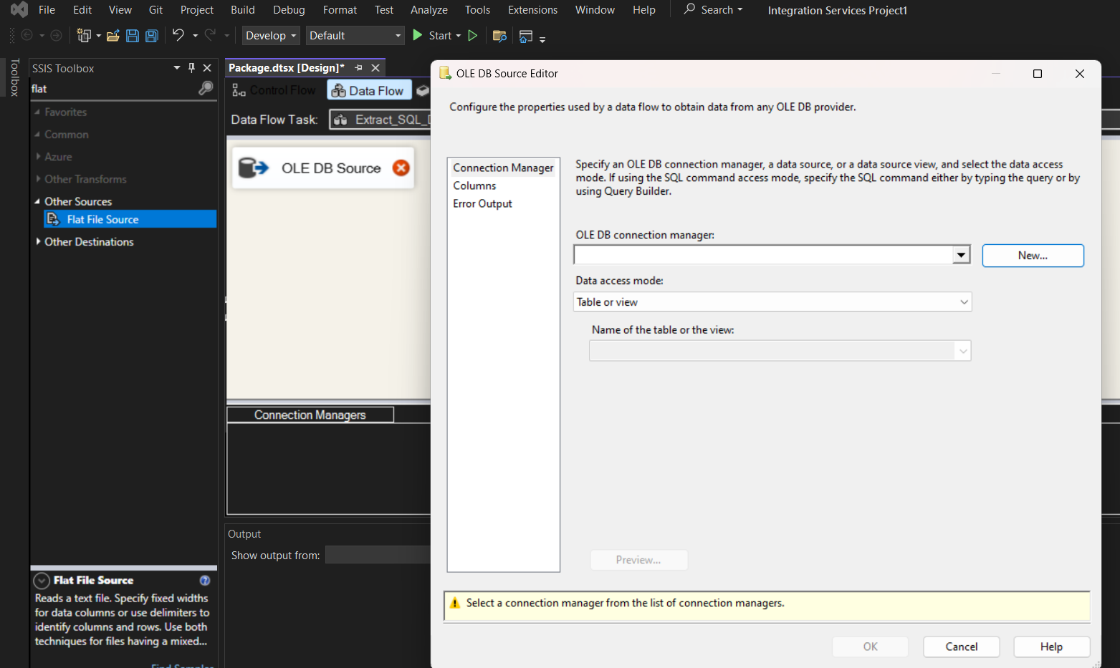

Connecting OLEDB (visual Studio) with my SQL server.
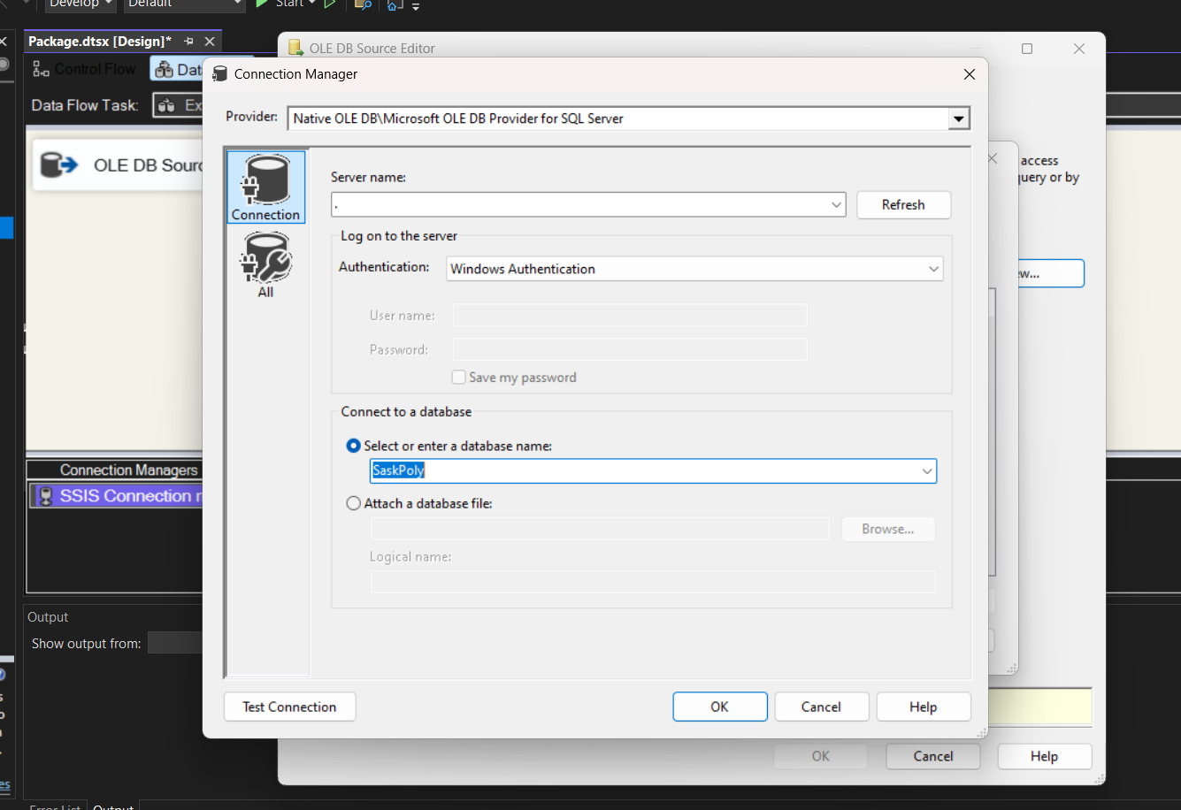
Connecting and SQL query command in OLE DB
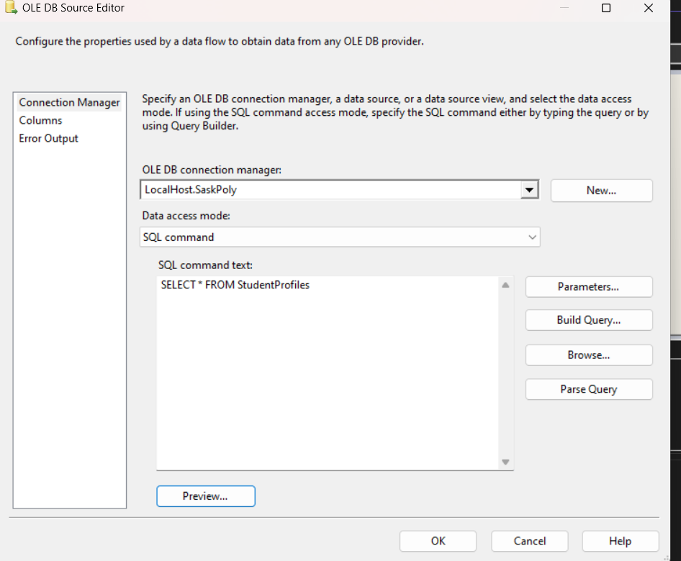
Get preview of SQL database in visual studio:
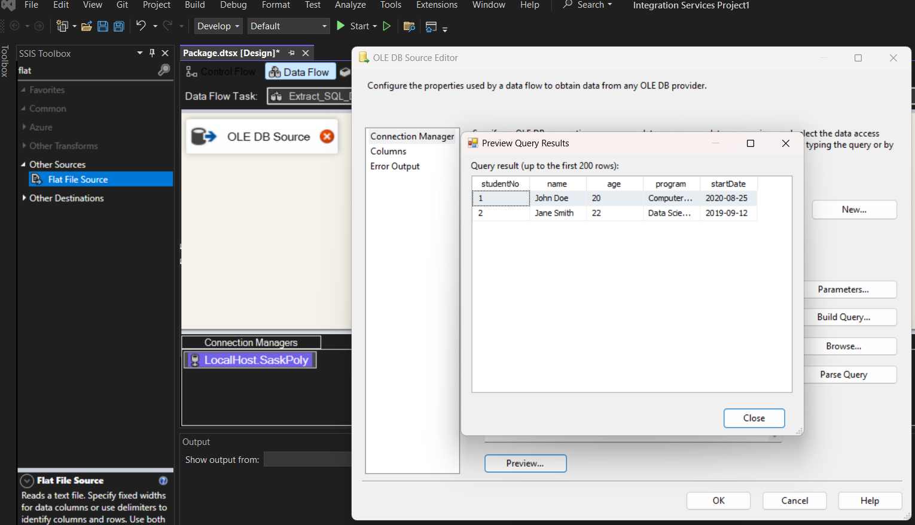
Creating Flat File Destination.
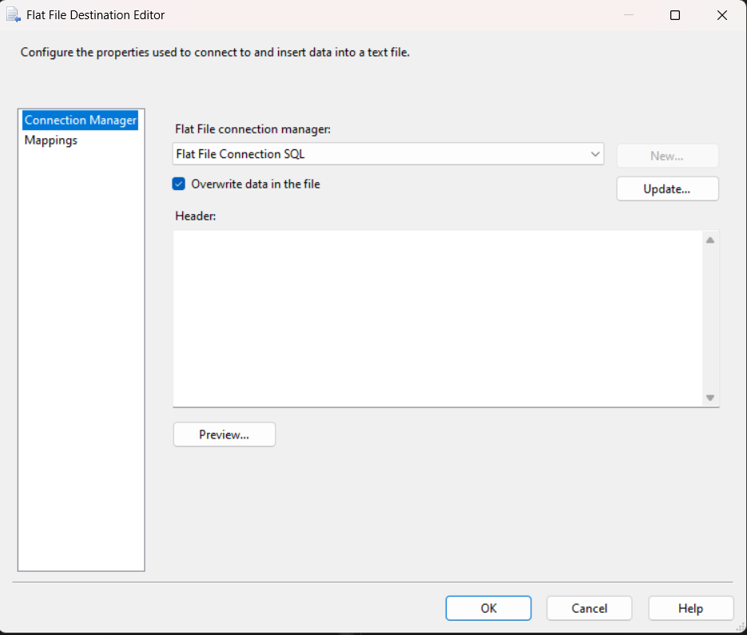

Step 6: connecting OLE DB source to Flat File Destination and run Visual Studio Project to establish connection.
Start now:
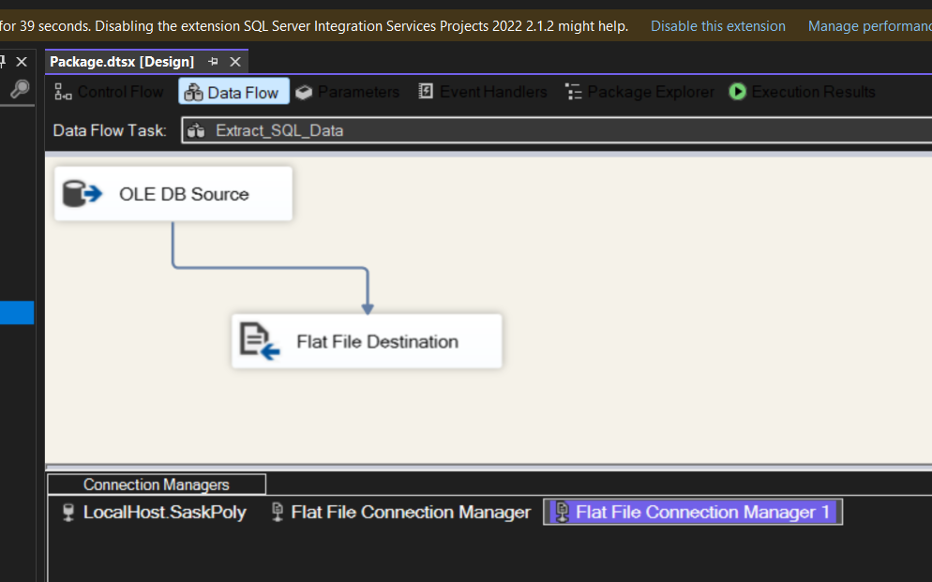
Execution Result:
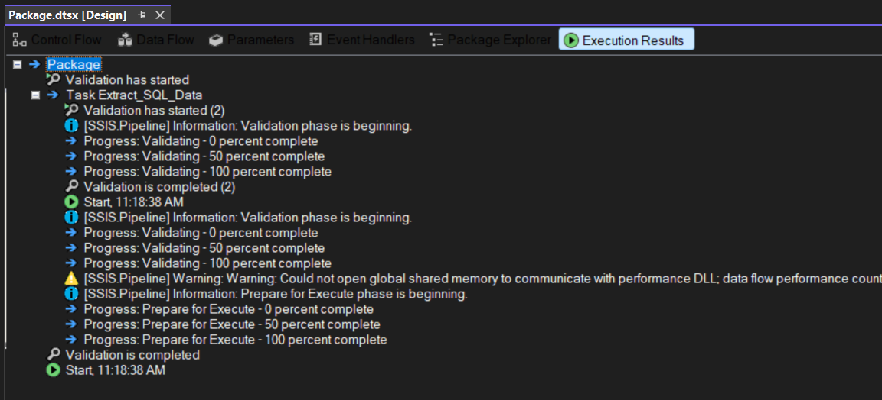

Connection is all set for first step (Visual Studio to SQL database)s:
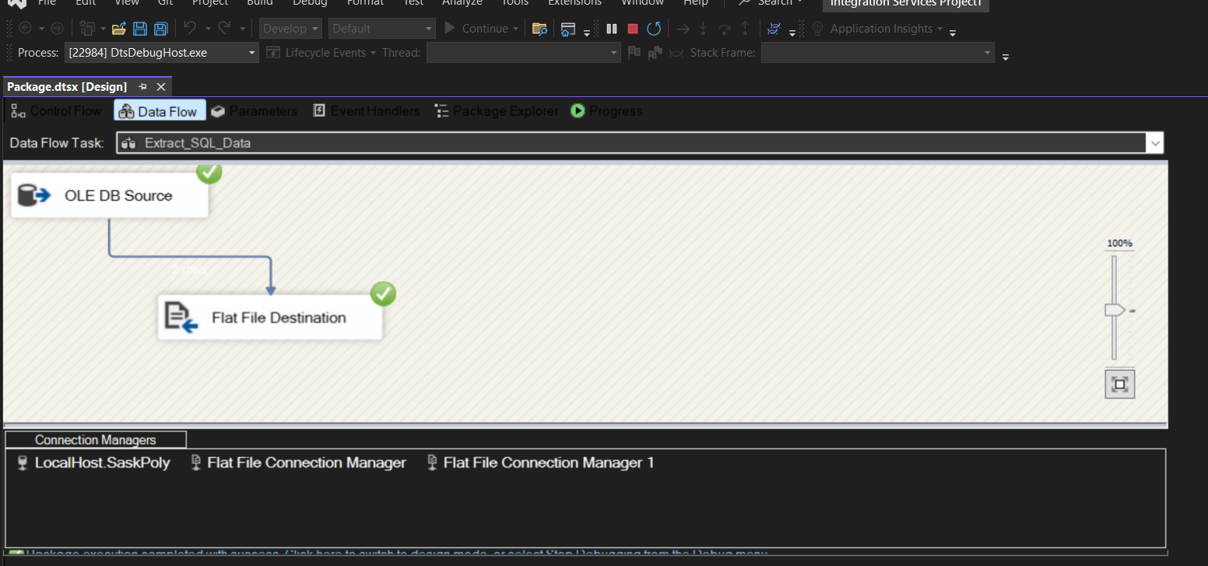

SQL connection Part all set and done.

Visual Studio Connection with MongoDB:
Installation of CDATA SSIS for integration services:
CDATA SSIS component for MongoDB installed:
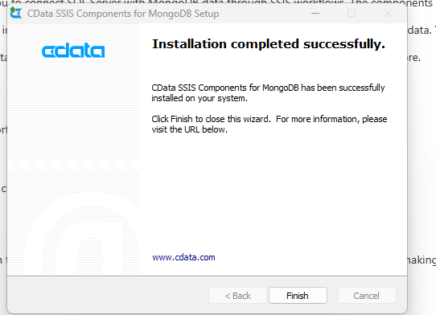

Creating connection manager to establish connection between Visual Studio and MongoDB
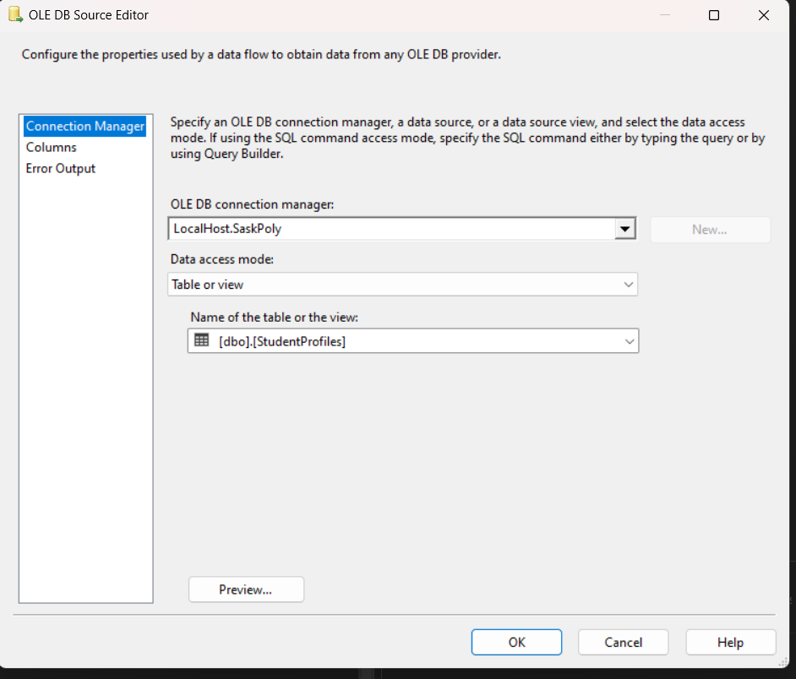

Creating source connection manager for MongoDB activityLogs File:
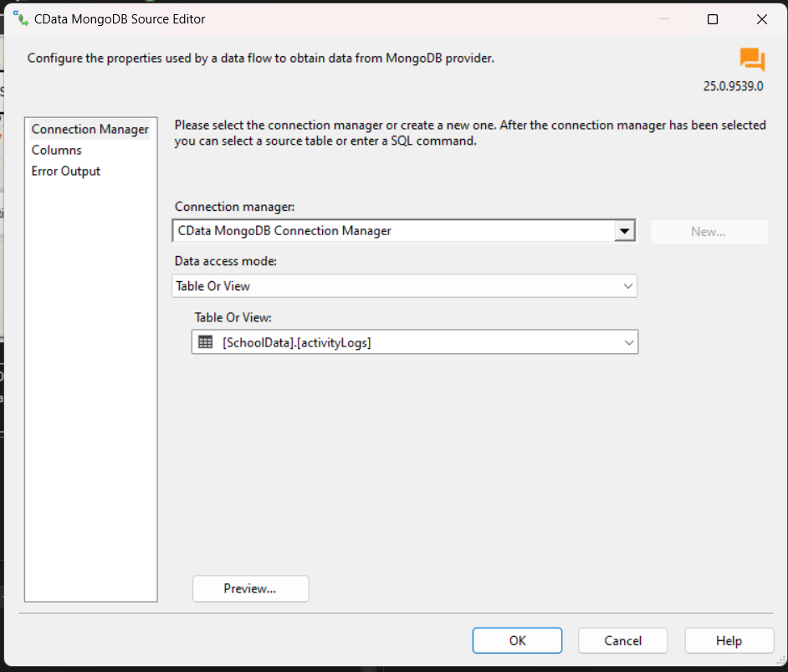

Creating flat file destination for activityLogs data.
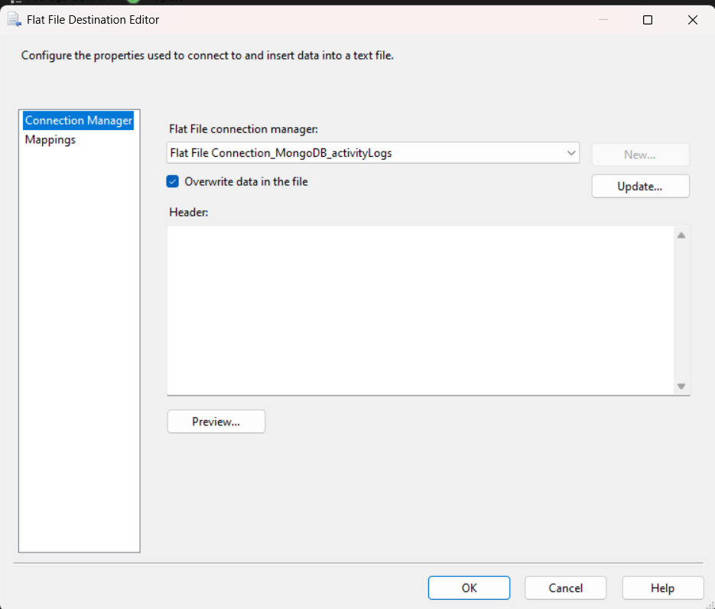

Creating MongoDB connection for media File data.
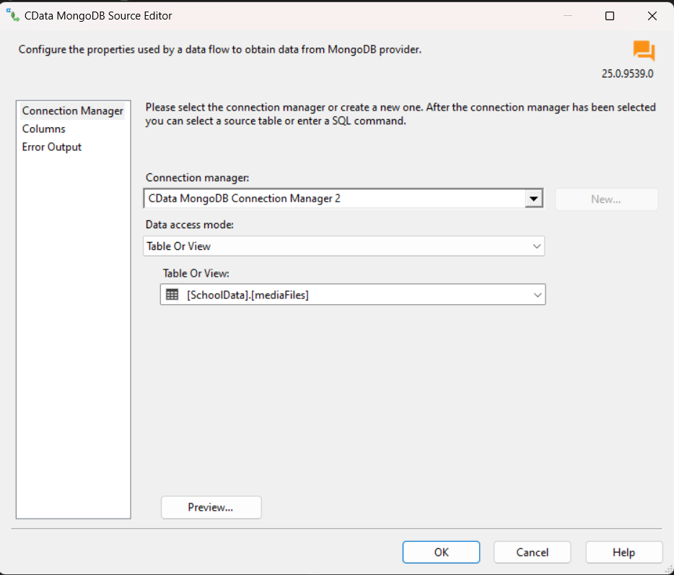

Creating Flat File destination for Media File data:
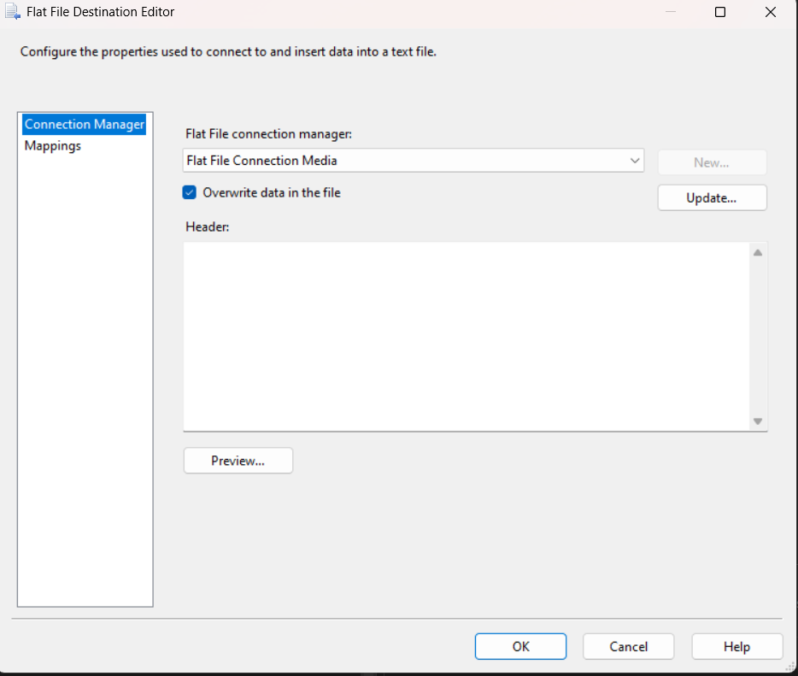

Run project and get final connection established.
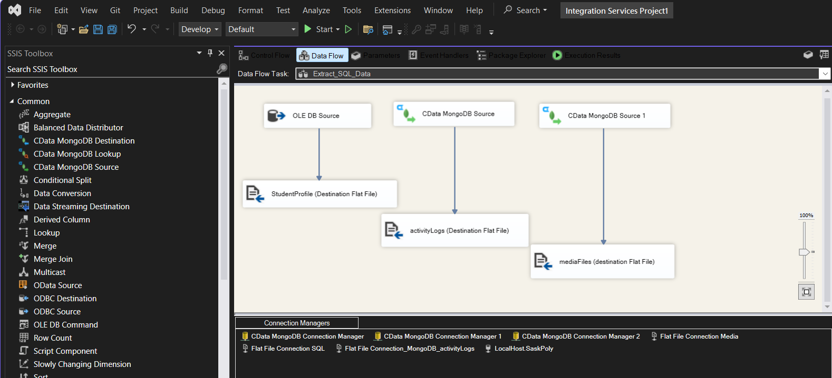

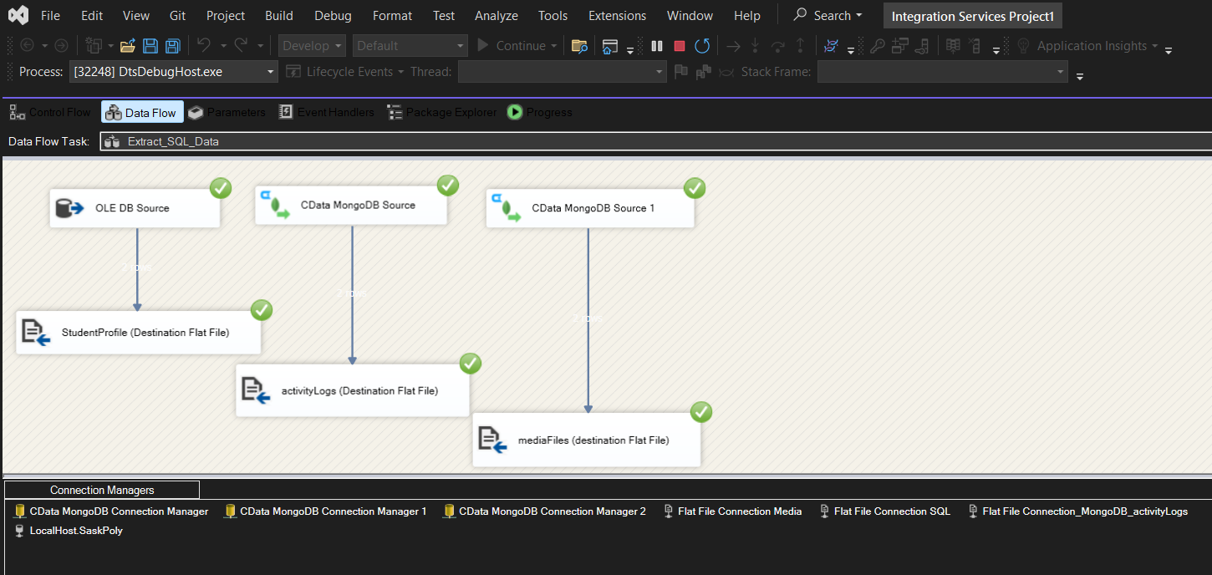

Final output (files and folder inside Data Lake)
